PLEASE COMPLETE IN BLOCK CAPITALS. PLEASE SUBMIT THE APPLICATION BY MAY 26 (WED), 2021.
Please read the guidelines carefully and make sure that all requested information is complete.

1. EXHIBITION OUTLINE
- Event Name : Craft Trend Fair 2021
- Dates : November 18 (THU) - 21 (SUN), 2021
※ Booth Installation & Display : November 17 (WED), 2021
- Venue : Coex Hall C (Seoul, Korea)
- Host : Ministry of Culture, Sports and Tourism
- Organizer : Korea Craft & Design Foundation

2. CONTACT DETAILS
Booth Title | (Company Name)
Manager Name
Phone Number
E-mail Address
Address | (zip code)
Web Address
Field | □ Tableware & Kitchen □ Objet & Deco □ Fashion & Accessories □ Furniture & Lighting □ Lifestyle & Office □ Etc. ( )
3. BOOTH TYPE / SCALE
Booth  Standard  &  Fee | ☐ No. of Booth request ______ (1 booth = 3m x 3m (9 m²) )  Participant can request 2 or 4 booth space in Art&Heritage zone.  ☐ Type A) Artist Discovery Project participant : 3,000,000 KRW / per 2 booth  ☐ Type B) Artist Discovery Project Non-participant :1,200,000 KRW / per 2 booth  ※ Booth fee may differ by the condition of Artist Discovery Project participation of the Art & Heritage Zone applicant. Please see below regard the Artist Discovery Project. | 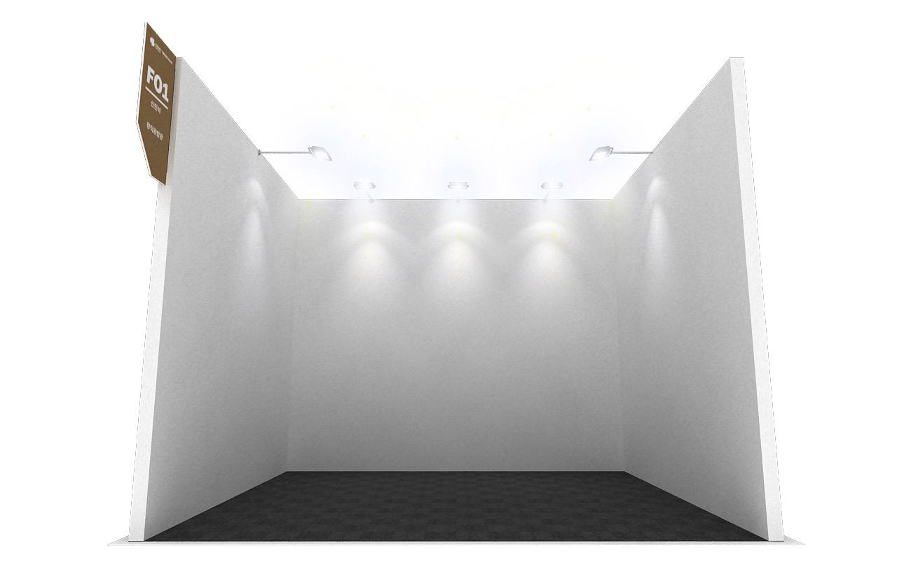  Standard Booth Image
Notice | • Please submit the application form and portfolio via email to craftfair@kcdf.kr by May 26 (WED), 2021 to complete your application.  • Please submit your gallery business registration certificate (or equivalent) at the time of application.  ※ Participants who select 'Type B' are encourage to participate for the Artist Discovery Project that selects artists from the Selected New Wave Zone and Brand Zone to provide free exhibition in the following year. (Please see details on next page.)  ※ All booths allocation is done by KCDF.  ※ Additional facilities request such as phone lines, additional power, furniture, etc. will incur additional charge, and has to be notified to organizer ahead. (Details will be notified separately after evaluation period.)  ※ Electrical outlet: 220 V

1. TERMS OF REFERENCES Terms and Regulations for Exhibitors:
a. The term `Exhibitor' shall include all employees, personnel and agents of any company, partnership, firm or individual to which space has been allocated for the purpose of exhibiting.
b. The term `Exhibition' shall mean the Exhibition of the Craft Trend Fair.
c. The term 'Organizer' shall mean the Organizing Committee of the
Craft Trend Fair.

2. APPLICATION FOR PARTICIPATION
a. All applications for participation shall be made on the application
form, which shall be submitted to the organizer(craftfair@kcdf.kr).
b. The contract shall be established when the exhibitor submits the
application form and completed with payment of the participation fee.

3. ALLOCATION OF EXHIBIT SPACE
a. The organizer shall allocate space in accordance with the nature of the exhibit or in the manner the organizer deems fit.
b. The organizer shall reserve the right to change the space allotment for the exhibitor at any time prior to the build-up of the exhibition. If there are any exceptional circumstances or demands, such changes shall be made at the discretion of the organizer, and the exhibitor shall have no claim for compensation as a result of the changes.

4. USE OF EXHIBIT SPACE
a. Exhibitors are bound to exhibit the announced products and to manage the exhibits with competent personnel during the open hours of the exhibition.
b. All exhibits must be in accordance with the description provided on the application form and be related to the theme of the exhibition.
c. Exhibitors may not sublet the space allotted to them to third parties either wholly or in part without the written consent of the organizer.
d. Modifications, including decorations such as painting of floors,
ceilings or pillars, will not be permitted, and the exhibitor shall compensate for any consequent damages to the exhibition.

5. TERMS OF PAYMENT
a. Exhibitors must pay booth charges by the due date September 30 (THU), 2021, and method of payment will be sent via email notification separately.
b. Booth participation will be automatically cancelled in case of failed payment by due date, and the booth will be allocated to the next in line.

6. BREAK OF CONTRACT AND WITHDRAWAL BY EXHIBITOR
a. In the event of abandonment or rejection of the allocated space, the organizer has the right to cancel the exhibitor's application. In this case, the exhibition deposit will not be refunded.
b. In the event of partial abandonment or rejection of the allocated space, the organizer has the right to cancel the application and reallocate the partly abandoned or rejected space.
c. In the event of that the exhibitor cancels the participation, 100% refund of paid fee if canceled by October 15, 2021 and no refund can be made after that.

7. ARTIST DISCOVERY PROJECT
a. The participant must report via email to KCDF(craftfair@kcdf.kr) by February 28, 2022 on the artist discovery project with the selected artist and the exhibit schedule.
b. The Artist Discovery Project exhibit will take place between March and November 2022, and must exhibit for 7 days or more. The cost of the exhibition must be borne by the gallery. The contents related to exhibit contracts should be prepared by negotiating between the selected artist and the gallery.
c. In the event of abandonment or rejection of the gallery not following the contract of inform on the project report, or exhibit by above period of contract dates, the organizer has right to claim back with the booth charge as non-participant of the Artist Discovery Project, and the gallery is obligated to repay the difference of the booth fee payment 800,000 KRW per booth as by following.
※ Additional amount : 3,000,000 KRW - 1,200,000 KRW = 800,000 KRWx No. of booths
d. In case of failed payment, there will be restrictions on participation in all events organized by kcdf.

8. CHANGES
a. The organizer reserves the right to change the venue and duration of the exhibition under exceptional circumstances or demands. In the event of a change of venue and/or cancellation of the exhibition date, half of the exhibition deposit will be refunded to the exhibitors. But when the events are caused by the following causes: strike, lockout, injunction, emergency, act of God, act of war or any other cause beyond control of the Exhibit Management, the deposit will not be refunded.

9. CONSTRUCTION AND DECORATION OF STANDS
a. All exhibitors must complete their construction and/or decoration by the date and time stipulated by the organizer.

10. REMOVAL OF EXHIBITS
a. Exhibitors shall remove all exhibits from the exhibition hall within the period stipulated by the organizer and shall indemnify the organizer against any loss by reason of delay or damage to the exhibition hall.
b. Exhibitors should dispose of waste(especially industrial wastes such as floor carpet) upon the responsibility. If an exhibitor does not treat waste properly, the organizer can charge an exhibitor for the cost of refuse disposal.

11. SECURITY AND INSURANCE
a. The organizer shall take all reasonable security precautions in the interests of exhibitors and visitors.
b. The organizer shall not be held responsible for any loss or theft of or damage to exhibits at the exhibition hall during the build-up, exhibition and dismantling periods.
c. The organizer shall not be held responsible for any loss of or damage to exhibits or articles belonging to the exhibitor. Exhibitors are responsible for acquiring all the necessary insurance policies.

12. FIRE REGULATIONS
a. Materials used in booth and display construction must be properly
fireproofed in accordance with regulations of the Organizing Committee.
b. The organizer has the right, should circumstances necessitate, making changes to the exhibitor's booth, in the interest of the control of exhibits.

13. SUPPLEMENTARY CLAUSES
a. Whenever necessary, the organizer shall have the right to issue
supplementary regulation in addition to those in the Terms and Regulations for Exhibitors to ensure the smooth management of the exhibition.
b. Any additional written regulatory instruction shall form part of the Terms and Regulations for Exhibitors and they shall be binding on the exhibitions.

14. SETTLEMENT OF DISPUTES
a. In the event of different ideas in the interpretation of the Terms and
Regulations for Exhibitors between the organizer and exhibitors, the organizer’s interpretation shall take priority.
b. A Dispute regarding this matter should follow the decision of The Korean Commercial Arbitration Board, and filing the petition on the decision will not be acceptable.

Agreement
I, the undersigned agree that I have no objection to all of the above and will faithfully fulfill my obligations as a contractor.

Signature

